Experiment No: 9
Title : Binary Search Tree Operations
Aim:
To implement various operations on a Binary Search Tree (BST) such as insertion, searching, deletion, and in-order, pre-order and post-order traversal using the C programming language.

Objectives:
- Understand the concept and properties of a Binary Search Tree.
- Implement BST operations: Insert, Search, Delete, and In-Order Traversal.
- Analyze time complexity of different operations.
- Gain practical experience with tree-based data structures in C

Requirements:
- Basic knowledge of C programming
- Understanding of pointers and dynamic memory allocation
- Familiarity with recursion
- Text editor and GCC compiler (or any C compiler)

Description:
A Binary Search Tree (BST) is a binary tree in which every node follows the properties:
- The key in the left subtree is less than the root node.
- The key in the right subtree is greater than the root node.
- Both left and right subtrees are also BSTs.
BSTs provide efficient insertion, deletion, and lookup operations in O(log n) average time.

Algorithms:

1. Insertion:
Insert(root, key):
if root is NULL:
return new node with key
if key < root->data:
root->left = Insert(root->left, key)
else if key > root->data:
root->right = Insert(root->right, key)
return root

2. Search:
Search(root, key):
if root is NULL or root->data == key:
return root
if key < root->data:
return Search(root->left, key)
else:
return Search(root->right, key)

3. Deletion:
Delete(root, key):
if root is NULL:
return root
if key < root->data:
root->left = Delete(root->left, key)
else if key > root->data:
root->right = Delete(root->right, key)
else:
if root has no child:
delete root
return NULL
if root has one child:
return the child
if root has two children:
temp = findMin(root->right)
root->data = temp->data
root->right = Delete(root->right, temp->data)
return root

4. In-order Traversal (Left → Root → Right):
InOrder(root):
if root != NULL:
InOrder(root->left)
print root->data
InOrder(root->right)

5. Pre-order Traversal (Root → Left → Right):
PreOrder(root):
if root != NULL:
print root->data
PreOrder(root->left)
PreOrder(root->right)

6. Post-order Traversal (Left → Right → Root):
PostOrder(root):
if root != NULL:
PostOrder(root->left)
PostOrder(root->right)
print root->data

Conclusion:
The implementation of Binary Search Tree operations in C demonstrates how hierarchical data structures can be efficiently managed using recursion and pointers. With all three traversals (in-order, pre-order, and post-order), the program showcases how to access and process data in various ways, each suitable for different types of problems (e.g., sorting, expression tree evaluation). This project reinforces key data structure principles and improves problem-solving using trees

C Programming Code:
#include <stdio.h>
#include <stdlib.h>

// Define structure for a BST node
struct node {
int data; // stores the value of the node
struct node *left, *right; // pointers to left and right child
};

// Function to create a new node with given value
struct node* createNode(int value) {
struct node* newNode = (struct node*)malloc(sizeof(struct node)); // allocate memory
newNode->data = value; // set data
newNode->left = NULL; // initialize left child
newNode->right = NULL; // initialize right child
return newNode;
}

// Function to insert a new value into the BST
struct node* insert(struct node* root, int value) {
if (root == NULL) {
// If tree is empty, new node becomes root
return createNode(value);
}
if (value < root->data) {
// If value is smaller, insert in left subtree
root->left = insert(root->left, value);
}
else if (value > root->data) {
// If value is larger, insert in right subtree
root->right = insert(root->right, value);
}
// If value already exists, do nothing
return root;
}

// Function to find node with minimum value in a subtree
// (Used while deleting node with two children)
struct node* findMin(struct node* root) {
while (root && root->left != NULL)
root = root->left; // move left until leaf
return root;
}

// Function to delete a node from BST
struct node* deleteNode(struct node* root, int value) {
if (root == NULL)
return root; // if tree empty

if (value < root->data) {
// value is smaller, search in left subtree
root->left = deleteNode(root->left, value);
}
else if (value > root->data) {
// value is larger, search in right subtree
root->right = deleteNode(root->right, value);
}
else {
// Node found ? delete it

// Case 1: Node has only right child or no child
if (root->left == NULL)
{
struct node* temp = root->right;
free(root);
return temp;
}
// Case 2: Node has only left child
else if (root->right == NULL) {
struct node* temp = root->left;
free(root);
return temp;
}

// Case 3: Node has two children
// Find inorder successor (smallest in right subtree)
struct node* temp = findMin(root->right);
// Copy its data to current node
root->data = temp->data;
// Delete the inorder successor
root->right = deleteNode(root->right, temp->data);
}
return root;
}

// Inorder Traversal: Left ? Root ? Right
void inorder(struct node* root) {
if (root != NULL) {
inorder(root->left); // visit left subtree
printf("%d ", root->data); // visit root
inorder(root->right); // visit right subtree
}
}

// Preorder Traversal: Root ? Left ? Right
void preorder(struct node* root) {
if (root != NULL) {
printf("%d ", root->data); // visit root
preorder(root->left); // visit left subtree
preorder(root->right); // visit right subtree
}
}

// Postorder Traversal: Left ? Right ? Root
void postorder(struct node* root) {
if (root != NULL) {
postorder(root->left); // visit left subtree
postorder(root->right); // visit right subtree
printf("%d ", root->data); // visit root
}
}

// Main function with menu-driven program
int main() {
struct node* root = NULL; // start with empty tree
int choice, value;

while (1) {
// Display menu
printf("\n--- Binary Search Tree Operations ---\n");
printf("1. Insert\n");
printf("2. Delete\n");
printf("3. Inorder Traversal\n");
printf("4. Preorder Traversal\n");
printf("5. Postorder Traversal\n");
printf("6. Exit\n");
printf("Enter your choice: ");
scanf("%d", &choice);

switch (choice) {
case 1:
// Insert new value
printf("Enter value to insert: ");
scanf("%d", &value);
root = insert(root, value);
break;

case 2:
// Delete given value
printf("Enter value to delete: ");
scanf("%d", &value);
root = deleteNode(root, value);
break;

case 3:
// Print Inorder (Ascending order)
printf("Inorder Traversal: ");
inorder(root);
printf("\n");
break;

case 4:
// Print Preorder
printf("Preorder Traversal: ");
preorder(root);
printf("\n");
break;

case 5:
// Print Postorder
printf("Postorder Traversal: ");
postorder(root);
printf("\n");
break;

case 6:
// Exit program
printf("Exiting program.\n");
exit(0);

default:
printf("Invalid choice! Please try again.\n");
}
}
return 0;
}
Output
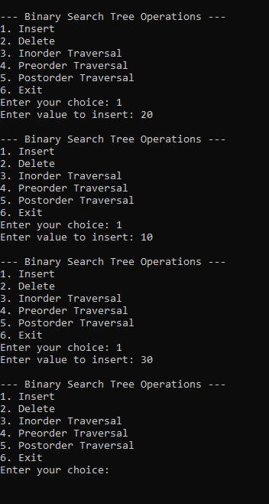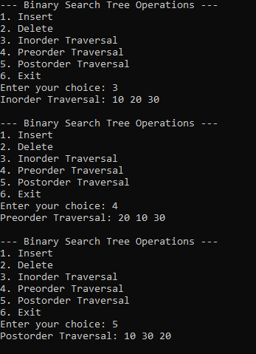

Viva Questions –

- What is a Binary Search Tree (BST)?
- What are the properties of a Binary Search Tree?
- What is the difference between a binary tree and a Binary Search Tree?
- What is the purpose of the insert() function in a BST?
- How do you search for an element in a BST?
- What are the three cases of node deletion in a BST?
- What is the difference between inorder, preorder, and postorder traversal?
- Why does inorder traversal of a BST display elements in ascending order?
- What is the average and worst-case time complexity of searching in a BST?
- What is the purpose of pointers and dynamic memory allocation in a BST?

Real-Time Examples of a Binary Search Tree:
- Dictionary and word lookup: Helps organize words or keys for faster searching.

- Database indexing: Tree-based structures help search and retrieve records efficiently.

- Student record management: Stores student roll numbers for searching, insertion, and deletion.

- Library management system: Organizes book IDs to locate and manage book records.

- Contact management: Organizes contact IDs or names to support searching and updating.

- Inventory management: Stores product IDs for finding, adding, or removing products.

- File systems: Tree-based structures help organize files and directories, although these are generally not BSTs.

- Online shopping systems: Can use tree-based indexes to search product records efficiently.

